1-

Topic: Pinecone Pals (Nature Art)
Episode: 202B Cold-Blooded; 203B Nature Art
Brief Activity Description: Make your own pinecone pals! Using pinecones and other natural materials, and/or recyclables/objects around the house, we offer suggestions for how to make your own pinecone pals. As this is a form of nature art, we would leave space for creativity, while providing enough guidance to get started for those children who need it.
Objective: This is as much about making something out of pinecones, as it is about exploring the outdoors around you to find the pieces that make your pal complete. In this activity, children are touching grass, leaves, pine needles, acorns and so on to see what they are like and how they might fit into their vision of the perfect pinecone pal(s).

2-4

Topic: Nature Art
Episode: 203 B Nature Art
Brief Activity Description: In this activity, we encourage children to ‘let nature be their inspiration.’ We provide concrete suggestions to get started, with room for creativity.
Objective: We can’t be out in nature all of the time, but we can capture the essence of our favorite moments and places by recreating it in art.

Topic: Make a Picture Frame; DIY Gifts
Episode: 203B Nature Art
Brief Activity Description: Using sticks and twigs, make a picture frame for your nature art.
Objective: This is an add on for the above nature art activity, but could also be a standalone as a suggestion for a handmade present (environmental science).

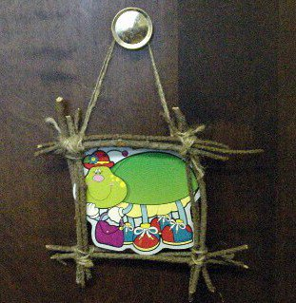

Topic: DIY Paint Brushes
Episode: 203B Nature Art
Brief Activity Description: Design your own paint brushes using natural materials, such as pine needles, juniper leaves, and dandelions.
Objective: Observe the patterns and textures you can make with the brushes. What is it like to paint with a dandelion flower versus a cluster of pine needles?

5-

Topic: Make a Nature Journal
Episode: 206A Enter the Dragonfly
Brief Activity Description: Every good nature explorer needs a trusty notebook. Using a basic blank spiral-bound notebook as your base, decorate the cover using natural materials (e.g. pressed leaves, ferns or flowers, pieces of birch bark, etc.,) or arts and crafts materials.
Objective: Part of scientific investigation is record keeping. At a young age, this can be done with drawings, tracings, and rubbings of things you find and see.

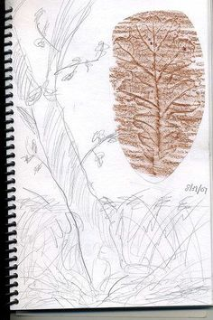

6-

Topic: Build a Model Igloo
Episode: 216A Snow Way to Keep Warm
Brief Activity Description: Using materials around the house (e.g. marshmallows, cotton balls, cardboard, etc.) build a model igloo.
Objective: Children will learn more about the insulating properties of snow, and the temporary shelters the Inuit build to stay warm and protect themselves from the cold.

7-

Topic: Make a Mini Greenhouse
Episode: 132B Water Cycle/Daisy’s Garden Corner
Brief Activity Description: Using materials found in a recycling bin, build a greenhouse, add some dirt and start plants for an outdoor garden or to transplant inside.
Objective: For a seed to sprout, it needs warm soil, sunlight and moisture. When you create a greenhouse for your seed and place somewhere that gets lots of sunlight, you help it grow faster. Observe how the greenhouse traps the heat from the sun and keeps in the moisture.

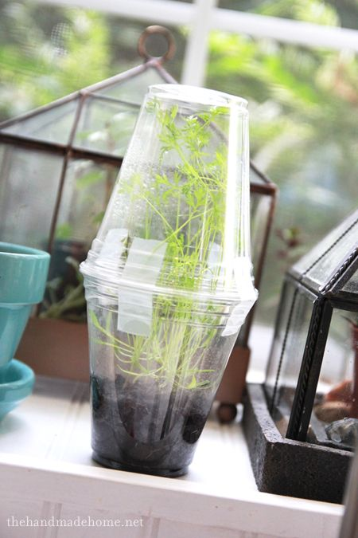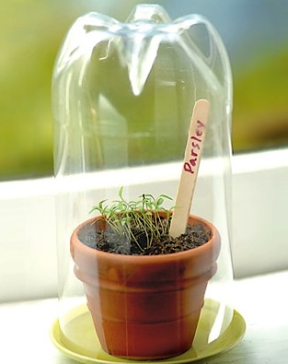

8-

Topic: Bugs; Bug Hotel
Episode: 204B Hal’s Hotel; 215B Save our Salad
Brief Activity Description: Build a bug motel to place outside to provide cover for beneficial insects in your garden or elsewhere. You can attract bees, ladybugs, beetles, moths and spiders, among others. A world without bugs would be a sad world, indeed! These “hotels” give insects a boost, especially those that are beneficial, giving them a place to hibernate, seek cover and lay eggs.
Objective: Learn about what makes a good habitat for particular bugs (e.g. tight spaces, moisture). What kind of design will attract them to your hotel?

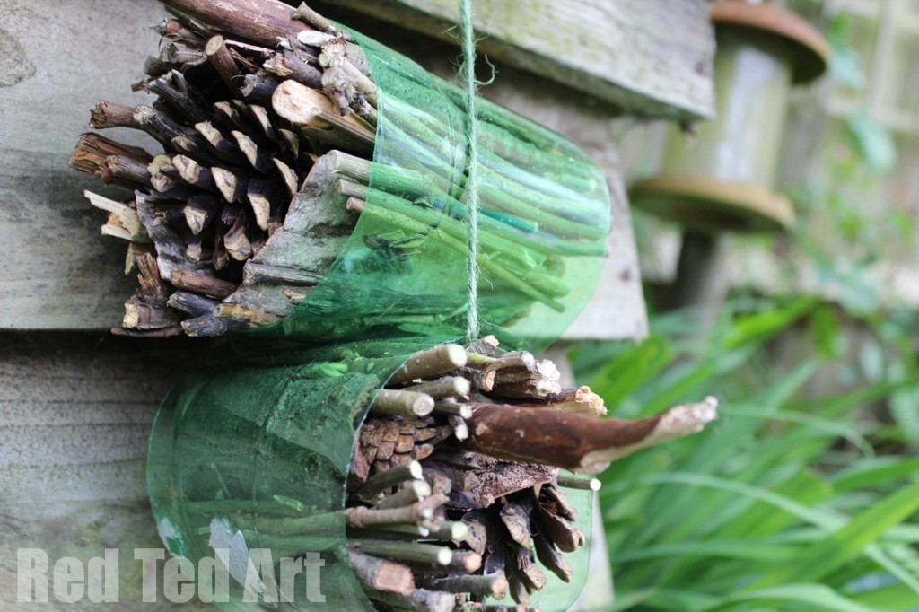

9-

Topic: Shadows; Make a Sundial
Episode: 137B Only the Shadow Knows
Brief Activity Description: Make a simple sundial and watch the shadows move to help you tell time.
Objective: What are shadows like throughout the day? The length of the stick (gnomon) doesn’t change, but does the shadow?

10-

Topic: Make a Backyard Nature Obstacle Course
Episode: 204A Houston’s Outdoor Adventure
Brief Activity Description: Using basic items found in the house (e.g. string and duct tape), as well as common items found outside (e.g. rocks and sticks), design a fun obstacle course for play and exercise.
Objective: Balance, coordination and strength are all useful for exploring the outdoors. Practicing is a great way to improve these skills.

